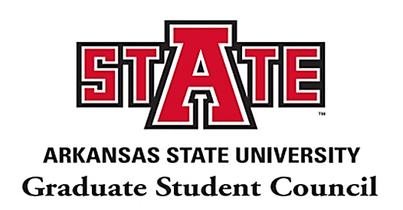
A-State Graduate Student Council Meeting Minutes
Monday, October 26th | 4:00PM – 5:00PM | Mockingbird Room, Reng Student Union

- The President Calls to Order at 04:00 PM (CST).

- President Reported on SGOC’s Friday’s Meeting and provided the following information: (1) Vote Yes/No for 2020FA01 “Simultaneous and sequential graduate degrees” and the deadline is October 30th; (2) Voted to include one voting member from the University College: There are eight (8) colleges now instead of the seven (7); (3) Voted in favor of the Graduate School Dean acting as an ex-officio; and the Book of Committees will be revised to keep it up-to-date.

Also, the President reported to the A-State Assessment Committee (AAC) (Oct. Meeting). She informed that the committee has split into two sub-committees to work on a graduate version of the “Leaving the Den” and “Alumni” surveys. She added that she is currently working on the “Alumni” Survey sub-committee. She also mentioned that the Vice-President, Sara Saucedo, is working with the “Leaving the Den” survey sub-committee.

- Vice President Reported on the International Student Health Forum. She expressed her appreciations who participated actively in sharing concern, asking questions, and providing feedback. She mentioned that there will be an International Student Insurance Workshop on November 5th. She also encouraged all students to contact: Kimberly Winters, kwinter@astate.edu and Mallory Yarbrough, msluder@astate.edu for additional questions.

Later, she reported on “Virtual Bingo” held on Oct 23rd. She thanks all participants and congratulates the Bingo prize winners. She announced that we will have more virtual games in the future, and encouraged all to look out for those announcements. Also, she mentioned that Covid-19 survey will be sent to all to receive the general feedback from students and the results will be conveyed to the Faculty Senate. She informed us that the survey link will be posted on our website, social media (Facebook/instagram), and in our next monthly newsletter. In the end, she reported on the GSC Monthly Newsletter. She encouraged all participants to submit the “Student Highlight Nomination Form” through GSC email at gsc@smail.astate.edu which is available on the GSC webpage.

- Secretary reported on General Body Meeting Minutes. He mentioned that all past meeting minutes are available on the GSC webpage. He encouraged all participants to look at the minutes to know more about it and what issues were discussed previously.

- Treasurer reported on the current Budget. He provided on the recent costs and expenditures and remaining balance.

- Communications Chair reported on “Trivia Game” and “Gift cards”. He led the event and played major roles for making the event more successful. Two participants were selected among all participants and gift cards were provided to them. He mentioned that the GSC will continue the similar event in every general body meeting. He encouraged all to spread this news to all other students and colleagues to make our event successful.

- Outreach Chair reported on the upcoming events as follows:
      - Graduate Curriculum Vita Workshop
Thursday, October 29, 2020 at 03.00 PM(CST)
Meeting ID: 983 2794 7006
Passcode: 029633
      - International Student Services Insurance Workshop
November 5, 2020 from 01:30 to 02:30 PM (CST)
(Note: A Zoom link will be sent out during the week of the event. For more information please contact Kimberly Winters kwinters@astate.edu.)

      - November 13th to 15th (NAGPS 34th Annual Conference)
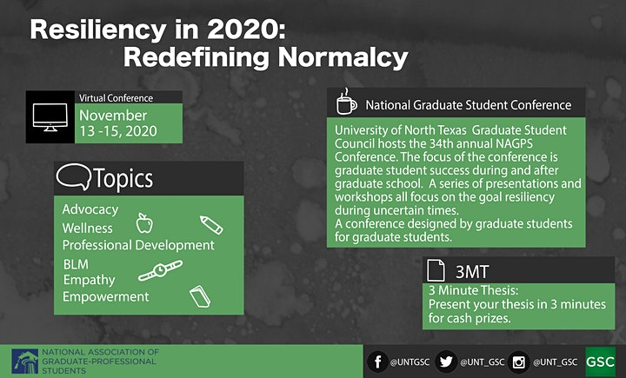
This year’s Theme is:Resiliency in 2020: Redefining Normalcy

In partnership with the Graduate Student Council at the University of North Texas (UNT), we're excited to gather student leaders from across the country for a 3-day Zoom conference of membership engagement, academic achievement, and the development of the Association’s advocacy platform.

Event Registration Link: https://www.eventbrite.com/e/nagps-2020-national-conference-virtual-tickets-124215402613?aff=mailchimp

II. Open Floor: No additional question was received.

III. President adjourned the meeting at 05:00 PM(CST).

Contact Information: GSC Officers at 2020-2021 Academic Year

President: Alejandra Morales
E-mail: alejandr.morales@smail.astate.edu
Phone: 870-680-4818
Office: Reng Student Union, Suite 1909 (3rd Floor)

Vice-President: Sara Saucedo
E-mail: sara.saucedo@smail.astate.edu
Phone: 870-680-4818
Office: Reng Student Union, Suite 1909 (3rd Floor)

Secretary: Sumon Roy
Email: sumon.roy@smail.astate.edu
Phone: 870-680-4818
Office: Reng Student Union, Suite 1909 (3rd Floor)

Treasurer: Kyler Brinkley
Email: kyler.brinkley@smail.astate.edu
Phone: 870-680-4818
Office: Reng Student Union, Suite 1909 (3rd Floor)

Communications Chair: Jordan Shelton
Email: jordan.shelton1@smail.astate.edu
Phone: 870-680-4818
Office: Reng Student Union, Suite 1909 (3rd Floor)

Outreach Chair: Shanita Sanders
Email: shanita.sanders@smail.astate.edu
Phone: 870-680-4818
Office: Reng Student Union, Suite 1909 (3rd Floor)

